Sprint Meeting

Template:

September 1, 2024, at 8:00 PM

Writer/Leader: Syed Musavi

Participants: Hina, Haris, and Antonia

1. Backlog:
2. Goal:
3. Availability:
4. Task for next meeting:
5. Past tasks:
6. Issues:

September 4, 2024, at 8:00 PM

Writer/Leader: Syed Musavi

Participants: Hina and Haris

1. Backlog:
   1. Come Up with an idea for the project
      1. recipes cataloger
2. Goal:
   1. Decide if we want to stick with the same idea
      1. We decided that we would create an Affordable 3 step recipe cataloger
3. Availability:
   1. Everyone fills out the when2meet
4. Task for next meeting:
   1. All members create a layout of how you want the website to look like
5. Past tasks:
   1. None currently
6. Issues:
   1. No issues or questions currently

September 9, 2024, during class

Writer/Leader: Syed Musavi

Attendees: Syed, Hina, Haris

1. Backlog:
   1. Recipe Cataloger- Five Ingredient Recipes As the main appeal of the website but people can also store their recipes on the website as well.
2. Goal:
   1. We set weekly meetings outside of class
   2. Share vscode a file with the three people
   3. Start coding by next week
      1. Website data
         1. Title
         2. 5 Ingredient
         3. Tools/Steps (prep)
         4. Measurement
         5. Serving Size
         6. Category/Cusine type
      2. Agreement
         1. If they would like to post on the main forum they would need to agree to our user agreement
      3. Style
         1. Quizlet style where there are two slide shows one for the main forum and one for the personal category.
3. Availability:
   1. Syed Musavi - Citizenship test this week
   2. Hina Osto- Not able to attend in-person
   3. Haris Bashir- Not able to attend in-person
4. Task for next meeting:
   1. Create a shared vscode file with everyone (Haris or Hina)
   2. Create a timeline for the project (Syed)
5. Past tasks:
   1. Create an example output (Completed)
   2. When2meet schedule (Completed)
6. Issues:
   1. We have to determine how we want to create the code and what is the best way of creating it.
   2. Hina Osto talked to the professor about joining through Zoom.

September 10, 2024, at 4:00 PM

Writer/Leader: Syed Musavi

Participants: Syed

1. Backlog:
   1. That the idea has been finalized 5 recipe
      1. Website data
         1. Title
         2. 5 Ingredient
         3. Tools/Steps (prep)
         4. Measurement
         5. Serving Size
         6. Category/Cusine type
      2. Agreement
         1. If they would like to post on the main forum they would need to agree to our user agreement
      3. Style
         1. Quizlet style where there are two slide shows one for the main forum and one for the personal category.
2. Goal:
   1. We all should read and understand the rubric, and figure SRS for this project.
3. Availability:
   1. Nothing is stopping anyone from this meeting task
4. Task for next meeting:
   1. Haris creates 50 recipes for 5 ingredients recipes with pictures (overarching)
   2. Syed Front-End Layout Blueprint
   3. Hina started the file after meeting/Share file VScode
5. Past tasks:
   1. Creating a timeline (Syed)
      1. 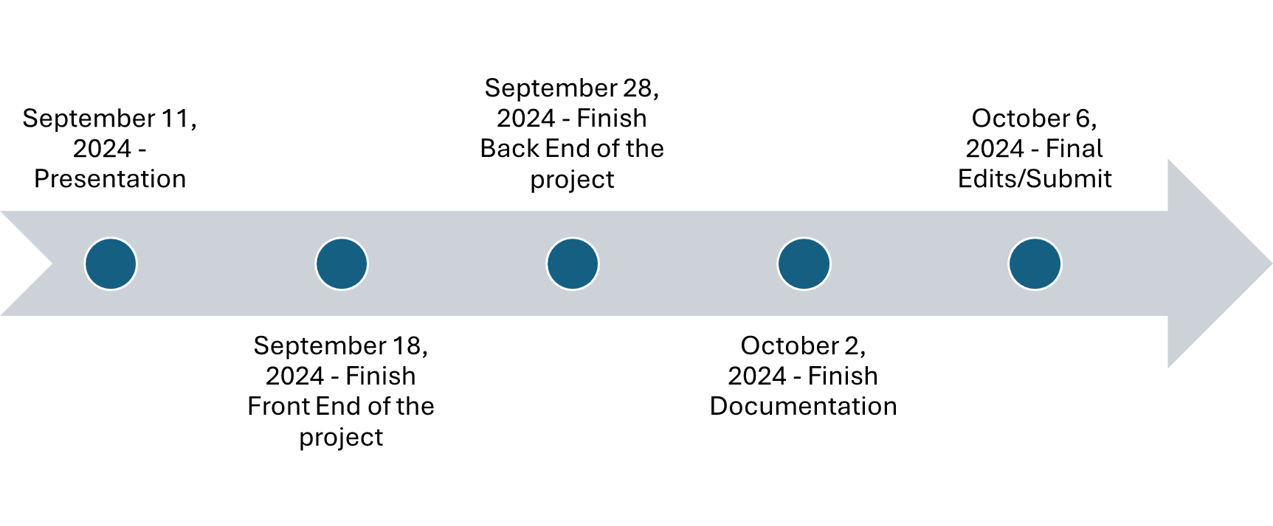
   2. Shared VScode created (Not done)
6. Issues:
   1. Hina can only join online (talked to the professor)

September 11, 2024, at 4:00 PM

Writer/Leader: Syed Musavi

Participants: Hina, Haris, and Antonia

1. Backlog:
   1. A background of what we want to create has been done we currently need to start coding/documentation
2. Goal:
   1. Have a meeting with the professor
   2. Program in Python is a requirement, a key structure and who got the info (python file about gathering).
   3. Create a quality Manual
3. Availability:
   1. No meeting this weekend but tasks have been distributed to everyone.
4. Task for next meeting:
   1. Syed- create a process system that the team will use.
   2. Hina- Start the front end and share vscode file
   3. Haris - figure out what he meant by requirements and Python code
   4. Antonia - creates 50 recipes for 5 ingredients recipes with pictures (overarching)
5. Past tasks:
   1. Haris creates 50 recipes for 5 ingredients recipes with pictures (overarching)
   2. Syed Front-End Layout Blueprint (Done)
   3. Hina started the file after meeting/Share file VScode (Not done)
6. Issues:
   1. Hina can only join online (talked to the professor)
   2. Catch Antonia up to date because she is a new team member who just started.

September 16, 2024, at 8:00 PM

Writer/Leader: Syed Musavi

Participants: Hina, Haris, and Antonia

1. Backlog:
   1. We have a finalized idea website currently working on the requirements of the website.
2. Goal:
   1. Start prototyping the project so that we can improve it
3. Availability:
   1. No one has anything major going on
4. Task for next meeting:
   1. Syed creates a more in-depth sketch of what he wants of the website
   2. Hina figures out how to share
   3. Haris works on requirements
   4. Antonia 50 recipes
5. Past tasks:
   1. Syed- create a process system that the team will use. (Done)
   2. Hina- Start the front end and share vscode file
   3. Haris - figure out what he meant by requirements and Python code
   4. Antonia - creates 50 recipes for 5 ingredients recipes with pictures (overarching)
6. Issues:
   1. Hina can only join online (talked to the professor)
   2. Catch Antonia up to date because she is a new team member who just started.

September 17, 2024, at 8:00 PM

Writer/Leader: Syed Musavi

Participants: Hina, Haris, and Antonia

1. Backlog:
   1. The main thing from the previous meeting was catching Antiona up which team lead Syed did through a personal call.
2. Goal:
   1. We want to start looking at what needs to be added to the code and how to improve the project
3. Availability:
   1. No issues
4. Task for next meeting:
   1. Antonia catch up on the project
   2. Syed creates the SRS
   3. Hina works on the code
   4. Haris should finalize what is needed for the requirements
5. Past tasks:
   1. Done - Syed creates a more in-depth sketch of what he wants of the website
   2. Not done correctly - Hina figures out how to share
   3. Still working on it- Haris works on requirements
   4. 20 out the 50 done - Antonia 50 recipes
6. Issues:
   1. Hina can only join online (talked to the professor)
   2. Antonia needs to adjust to the project

September 18, 2024, at 8:00 PM

Writer/Leader: Syed Musavi

Participants: Hina, Haris, and Antonia

1. Backlog:
   1. We are in the final steps of the project we think that we are in a good spot we just talked with the professor and we are going to do a quick debrief of where we are at.
2. Goal:
   1. See where in the code we are at
   2. Talk about requirements and what is needed for them
   3. Talk about the quality of the work.
3. Availability:
   1. No one has anything major going on
4. Task for next meeting:
   1. Haris finishes requirements
   2. Antonia looks into code quality
   3. Antonia help Hina
   4. Hina finishes the code adds the details we talked about with the slide show and other features.
5. Past tasks:
   1. No past task was completed
6. Issues:
   1. Hina can only join online
   2. We are not sure what documentation is needed

September 23, 2024, at 8:00 PM

Writer/Leader: Syed Musavi

Participants: Hina, Haris, and Antonia

1. Backlog:
   1. The project is in a good spot currently we are all getting close to finishing, we have been assigned another mini project.
2. Goal:
   1. Our goal for this meeting is to discuss the mini project and what to do we decided on percy jackson.
3. Availability:
   1. Syed has a physics exam next week
4. Task for next meeting:
   1. Syed Will create the requirements and give everyone their scripts for the movie project
   2. Hina will continue working on the code which should be completely done by wednesday
   3. Antiona will work on documentation
   4. Haris will start on HW4
   5. Syed will create control plan
5. Past tasks:
   1. No past task was completed
6. Issues:
   1. Syed will be busy this week
   2. Haris is unavailable during the weekend
   3. Hina can not come inperson

September 26, 2024, at 8:00 PM

Writer/Leader: Syed Musavi

Participants: Hina, Haris, and Antonia

1. Backlog:
   1. We are working on the finalization of the project with code aspect, and documentation.
2. Goal:
   1. Talk through the features of the code to see what needs to be added and how it looks.
   2. Create a presentation for the project
   3. Talk through how everyone is feeling about the project
3. Availability:
   1. Syed has a physics exam on September 30.
4. Task for next meeting:
   1. Hina needs to user agreement and a specification that the person has to add specific characters.
   2. Antonia needs to create the presentation and then add information.
   3. Syed needs to add information to the presentation.
   4. Syed needs to create a control plan and process layout.
   5. Haris needs to look at task 1 of the HW4.
   6. Syed needs to upload the mini-project
5. Past tasks:
   1. Haris upload requirements
   2. Look into code quality and code compliance
   3. Finish the code
6. Issues:
   1. Hina cannot go to in person (already talked to prof)

September 29, 2024, at 8:00 PM

Writer/Leader: Syed Musavi

Participants: Hina, and Antonia

1. Backlog:
   1. The project recipe cataloguer demo is completed, and we have completed the majority of the presentation.
2. Goal:
   1. Finalize the presentation and the order in which we present and what we say.
   2. Talk through the demo
   3. See where we can improve for next time as a team.
   4. Talk about HW4
3. Availability:
   1. Tomorrow Hina and Antonia cannot make the presentation in person.
   2. Syed has a physics exam in the morning and will not be available until after 11:59 AM.
4. Task for next meeting:
   1. Practice your slides (Everyone)
   2. Create your own class within python (Everyone)
   3. Finish Control Plans (Syed)
   4. Upload Requirements to the presentation (Haris)
5. Past tasks:
   1. Completed - Create the presentation (Antiona)
   2. Completed - Add steps, user agreement, and a specification to the code (Hina)
   3. Completed - Finish SRS (Syed)
   4. Completed - Requirements (Haris)
6. Issues:
   1. Tomorrow Hina and Antonia cannot make the presentation in person